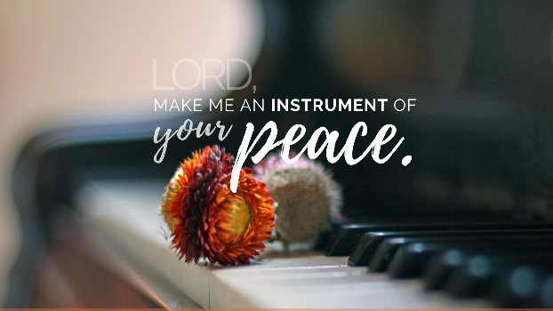

4 Tips to Pray By
By: Gary Stratman
Close the door---Take off your shoes
Open the windows---Fold your hands
1) Close the door - find a prayer closet - attempt to close the door to the distractions and clutter inside and out for a few moments each day - a regular time each day
2) Take off your shoes - remember not literally but seriously - no matter where we pray it is place to meet God - it is holy ground - probably not a burning bush like Moses - but God is present
3) Open the windows - missionaary Frank Laubach once said "I do nothing but open the windows, God does all the rest" You can do this by listening to your breath and saying a part of the prayer with each inhalation and another on the exhale…
4) Fold your hands - or open your hands - whatever prayer position helps you focus on God and let go of your stuff

4 Tips to Pray By
By: Gary Stratman
Close the door---Take off your shoes
Open the windows---Fold your hands
1) Close the door - find a prayer closet - attempt to close the door to the distractions and clutter inside and out for a few moments each day - a regular time each day
2) Take off your shoes - remember not literally but seriously - no matter where we pray it is place to meet God - it is holy ground - probably not a burning bush like Moses - but God is present
3) Open the windows - missionaary Frank Laubach once said "I do nothing but open the windows, God does all the rest" You can do this by listening to your breath and saying a part of the prayer with each inhalation and another on the exhale…
4) Fold your hands - or open your hands - whatever prayer position helps you focus on God and let go of your stuff

